Nama : Frederico Steven Kwok
NPM : 242310037
Kelas : TI-24-PA1
Mata Kuliah : Lab. Pemrograman Perangkat Bergerak
Tugas : Pertemuan 8 – Tugas dan Latihan
Github : https://github.com/RicoSteven120206/PPB-Praktikum-242310037.git
Pada tugas praktikum ini, mahasiswa diminta untuk mengembangkan fitur autentikasi lanjutan pada aplikasi e-catalog buku yang telah dibuat sebelumnya. Fokus utama tugas ini adalah membangun mekanisme registrasi pengguna, pembatasan akses berdasarkan status login (authentication guard), serta pengelolaan session melalui fitur sign-out.
Melalui tugas ini, mahasiswa diharapkan memahami konsep:
• Halaman Sign Up dengan request ke API
• Autentikasi dan kontrol akses
• Penyimpanan session menggunakan AsyncStorage
• Conditional rendering berdasarkan status login
• Manajemen session (Sign-Out)
Latihan 1: Halaman Sign-Up (Terhubung ke API)
Membuat halaman Sign Up (Registrasi) yang berisi:
• Input Username
• Input Email
• Input Password
• Input Re-Type Password
• Tombol Register
Ketentuan:
• Data dapat disimpan secara lokal (simulasi) menggunakan AsyncStorage.
• Lakukan validasi sederhana:
• Field tidak boleh kosong.
• Email harus berformat valid.
• Setelah registrasi berhasil:
• Wajib melakukan request ke endpoint POST https://fakestoreapi.com/users
• Jika berhasil tersimpan maka arahkan pengguna ke halaman Sign In.
• Jika tidak tampilkan informasi "Gagal membuat akun".
Tujuan dari fitur ini adalah mensimulasikan proses pembuatan akun pengguna pada aplikasi mobile.
Sumber: https://fakestoreapi.com/docs#tag/Users/operation/addUser
- Berikut untuk membangun Sign In dan Sign Up untuk Authentication pada suatu aplikasi E-Catalog Books, untuk Auth User untuk Autentikasi.
Source Code pada app/auth/signin.jsx
import { SafeAreaView } from "react-native-safe-area-context";
import { styles } from "../../styles/StyleApps";
import SignInForm from "../SignInForm";

export default function SignIn() {
return (
<SafeAreaView style={[styles.container, { justifyContent: "center" }]}>
<SignInForm />
</SafeAreaView>
);
}
Source Code pada app/auth/signup.jsx
import { useRouter } from "expo-router";
import { useState } from "react";
import {
ActivityIndicator,
Alert,
ScrollView,
Text,
TextInput,
TouchableOpacity,
View,
} from "react-native";
import { SafeAreaView } from "react-native-safe-area-context";
import { REGISTER_USER } from "../../../utils/api";
import { color_list, styles } from "../../styles/StyleApps";

const EMAIL_REGEX = /^[^\s@]+@[^\s@]+\.[^\s@]+$/;

export default function SignUp() {
const router = useRouter();
const [username, setUsername] = useState("");
const [email, setEmail] = useState("");
const [password, setPassword] = useState("");
const [retypePassword, setRetypePassword] = useState("");
const [isLoading, setIsLoading] = useState(false);

const handleRegister = async () => {
// Validasi: field tidak boleh kosong
if (
!username.trim() ||
!email.trim() ||
!password.trim() ||
!retypePassword.trim()
) {
Alert.alert("Error", "Semua field wajib diisi");
return;
}

// Validasi: format email
if (!EMAIL_REGEX.test(email.trim())) {
Alert.alert("Error", "Format email tidak valid");
return;
}

if (password.length < 6) {
Alert.alert("Error", "Password minimal 6 karakter");
return;
}

// Validasi: password harus sama dengan retype password
if (password !== retypePassword) {
Alert.alert("Error", "Password dan Re-Type Password tidak sama");
return;
}

setIsLoading(true);

const results = await REGISTER_USER({
email: email.trim(),
username: username.trim(),
password,
});

setIsLoading(false);

if (results.message) {
Alert.alert("Gagal", "Gagal membuat akun");
return;
}

if (results.data && (results.data.id || results.data.username)) {
Alert.alert("Berhasil", "Akun berhasil dibuat, silakan Sign In", [
{
text: "OK",
onPress: () => router.replace("/auth/signin"),
},
]);
} else {
Alert.alert("Gagal", "Gagal membuat akun");
}
};

return (
<SafeAreaView style={styles.container}>
<ScrollView
contentContainerStyle={{
flexGrow: 1,
justifyContent: "center",
paddingVertical: 40,
}}
showsVerticalScrollIndicator={false}
>
<View style={{ alignItems: "center", marginBottom: 30 }}>
<Text
style={{ fontSize: 24, fontWeight: "bold", color: color_list.green }}
>
Readly+
</Text>
<Text style={{ color: "gray", marginTop: 4 }}>Sign up to continue</Text>
</View>

<FormInput
placeholder="Username"
value={username}
onChangeText={setUsername}
autoCapitalize="none"
/>
<FormInput
placeholder="Email"
value={email}
onChangeText={setEmail}
keyboardType="email-address"
autoCapitalize="none"
/>
<FormInput
placeholder="Password"
value={password}
onChangeText={setPassword}
secureTextEntry={true}
/>
<FormInput
placeholder="Re-Type Password"
value={retypePassword}
onChangeText={setRetypePassword}
secureTextEntry={true}
/>

<TouchableOpacity
style={{
backgroundColor: color_list.green,
paddingVertical: 15,
borderRadius: 12,
alignItems: "center",
marginTop: 15,
opacity: isLoading ? 0.7 : 1,
}}
onPress={handleRegister}
disabled={isLoading}
>
{isLoading ? (
<ActivityIndicator color="#fff" />
) : (
<Text style={{ color: "#fff", fontWeight: "bold", fontSize: 16 }}>
Register
</Text>
)}
</TouchableOpacity>

<View
style={{ flexDirection: "row", justifyContent: "center", marginTop: 20 }}
>
<Text style={{ color: "gray" }}>Already have an account? </Text>
<TouchableOpacity onPress={() => router.push("/auth/signin")}>
<Text style={{ color: color_list.green, fontWeight: "bold" }}>
Sign In
</Text>
</TouchableOpacity>
</View>
</ScrollView>
</SafeAreaView>
);
}

const FormInput = (props) => (
<View style={{ marginBottom: 15 }}>
<TextInput
{...props}
style={{
borderWidth: 1,
borderColor: "#ddd",
borderRadius: 12,
paddingHorizontal: 15,
paddingVertical: 12,
fontSize: 15,
}}
/>
</View>
);

Source Code pada components/praktikum-8/SignInForm.jsx
import AsyncStorage from "@react-native-async-storage/async-storage";
import { useRouter } from "expo-router";
import { useState } from "react";
import {
ActivityIndicator,
Alert,
Text,
TextInput,
TouchableOpacity,
View,
} from "react-native";
import { AUTH_USER } from "../../utils/api";
import { color_list } from "../styles/StyleApps";

const SignInForm = ({ onSuccess, showSignUpLink = true }) => {
const router = useRouter();
const [username, setUsername] = useState("mor_2314");
const [password, setPassword] = useState("83r5^_");
const [isLoading, setIsLoading] = useState(false);

const handleSignIn = async () => {
if (!username.trim()) {
Alert.alert("Error", "Username cannot be empty");
return;
}
if (!password.trim()) {
Alert.alert("Error", "Password cannot be empty");
return;
}
if (password.length < 6) {
Alert.alert("Error", "Password must be at least 6 characters long");
return;
}

setIsLoading(true);
const results = await AUTH_USER({ username, password });

if (results.message) {
Alert.alert("Error", results.message);
setIsLoading(false);
return;
} else if (results.data && results.data.token) {
try {
const userData = {
username,
token: results.data.token,
loginTime: new Date().toISOString(),
};

await AsyncStorage.setItem("userData", JSON.stringify(userData));
await AsyncStorage.setItem("authToken", results.data.token);
setIsLoading(false);

if (onSuccess) {
onSuccess(userData);
} else {
router.replace("/main-apps");
}
} catch (error) {
console.error("Error saving user data:", error);
Alert.alert("Error", "Failed to save login data");
setIsLoading(false);
}
} else {
Alert.alert("Error", "Invalid response from server");
setIsLoading(false);
}
};

return (
<View style={{ paddingHorizontal: 20 }}>
<View style={{ alignItems: "center", marginBottom: 40 }}>
<Text style={{ fontSize: 24, fontWeight: "bold", color: color_list.green }}>
Readly+
</Text>
<Text style={{ color: "gray", marginTop: 4 }}>Sign in to continue</Text>
</View>

<View style={{ marginBottom: 15 }}>
<TextInput
placeholder="Username"
value={username}
onChangeText={setUsername}
autoCapitalize="none"
style={inputStyle}
/>
</View>

<View style={{ marginBottom: 10 }}>
<TextInput
placeholder="Password"
value={password}
onChangeText={setPassword}
secureTextEntry={true}
autoCapitalize="none"
style={inputStyle}
/>
</View>

<TouchableOpacity
style={{
backgroundColor: color_list.green,
paddingVertical: 15,
borderRadius: 12,
alignItems: "center",
marginTop: 20,
opacity: isLoading ? 0.7 : 1,
}}
onPress={handleSignIn}
disabled={isLoading}
>
{isLoading ? (
<ActivityIndicator color="#fff" />
) : (
<Text style={{ color: "#fff", fontWeight: "bold", fontSize: 16 }}>
Sign In
</Text>
)}
</TouchableOpacity>

{showSignUpLink && (
<View
style={{
flexDirection: "row",
justifyContent: "center",
marginTop: 20,
}}
>
<Text style={{ color: "gray" }}>Don't have an account? </Text>
<TouchableOpacity onPress={() => router.push("/auth/signup")}>
<Text style={{ color: color_list.green, fontWeight: "bold" }}>
Sign Up
</Text>
</TouchableOpacity>
</View>
)}
</View>
);
};

const inputStyle = {
borderWidth: 1,
borderColor: "#ddd",
borderRadius: 12,
paddingHorizontal: 15,
paddingVertical: 12,
fontSize: 15,
};

export default SignInForm;

Source Code pada utils/api.js untuk API dari fakestoreapi
import axios from "axios";

export const AXIOS_REQUEST = async (config) => {
try {
const response = await axios(config);
return { loading: false, message: "", data: response.data };
} catch (error) {
console.warn("Error in AXIOS_REQUEST:", error);

let errorMessage = "Failed to process request";

if (error.response) {
if (error.response.status === 401) {
errorMessage = "Invalid username or password";
} else if (error.response.status === 400) {
errorMessage = "Invalid request format";
} else if (error.response.status === 404) {
errorMessage = "Resource not found";
} else if (error.response.status === 500) {
errorMessage = "Internal server error";
} else {
errorMessage = `Server error: ${error.response.status}`;
}
} else if (error.request) {
errorMessage = "No response from server. Check your internet connection.";
} else {
errorMessage = error.message || "An unexpected error occurred";
}

return { loading: false, message: errorMessage, data: [] };
}
};

export const AUTH_USER = async (param) => {
try {
const config = {
method: "POST",
headers: { "Content-Type": "application/json" },
url: "https://fakestoreapi.com/auth/login",
data: param,
};

const response = await AXIOS_REQUEST(config);
console.log("AUTH_USER response:", response);
return response;
} catch (error) {
console.warn("Error in AUTH_USER:", error);
return {
loading: false,
message: "An unexpected error occurred during authentication. Please try again.",
data: [],
};
}
};

// Fungsi baru untuk Latihan 1: Registrasi (Sign Up)
export const REGISTER_USER = async (param) => {
try {
const config = {
method: "POST",
headers: { "Content-Type": "application/json" },
url: "https://fakestoreapi.com/users",
data: param,
};

const response = await AXIOS_REQUEST(config);
console.log("REGISTER_USER response:", response);
return response;
} catch (error) {
console.warn("Error in REGISTER_USER:", error);
return {
loading: false,
message: "An unexpected error occurred during registration. Please try again.",
data: [],
};
}
};

Source Code pada Header ketika suatu user sudah login akan mengubah nama user di header sesuai username. Components/praktikum-4/components/Header.jsx
import { Ionicons } from "@expo/vector-icons";
import { useFocusEffect } from "@react-navigation/native";
import { useRouter } from "expo-router";
import { useCallback, useState } from "react";
import { Text, TouchableOpacity, View } from "react-native";
import { checkLoginStatus } from "../../../utils/session";
import { styles } from "../../styles/StyleApps";

const Header = () => {
const router = useRouter();
const [userData, setUserData] = useState(null);

useFocusEffect(
useCallback(() => {
(async () => {
const data = await checkLoginStatus();
setUserData(data);
})();
}, [])
);

return (
<View style={styles.h_container}>
<View>
<Text style={styles.sub_title}>Good Morning👋</Text>
<Text style={styles.title}>{userData?.username || "Discover Books"}</Text>
</View>
<View style={{ flexDirection: "row", gap: 10 }}>
<TouchableOpacity
style={[styles.btn_icon, styles.shadow]}
onPress={() => router.push("/module-praktikum-4/search")}
activeOpacity={0.7}
>
<Ionicons name="search-outline" size={24} color="gray" />
</TouchableOpacity>

<TouchableOpacity
style={[styles.btn_icon, styles.shadow]}
onPress={() => router.push("/main-apps/qr-scanner")}
activeOpacity={0.7}
>
<Ionicons name="qr-code-outline" size={24} color="gray" />
</TouchableOpacity>

<TouchableOpacity style={styles.btn_icon}>
<Ionicons name="notifications-outline" size={24} color="gray" />
</TouchableOpacity>
</View>
</View>
);
};

export default Header;

Latihan 2: Pembatasan Akses Detail Buku (Authentication Guard)
Membuat mekanisme pembatasan akses (route protection) dengan kondisi sebagai berikut:
• Jika pengguna sudah Sign In:
• Pengguna dapat melihat halaman Detail Buku.
• Jika pengguna belum Sign In:
• Aplikasi tidak menampilkan detail buku.
• Pengguna diarahkan ke halaman Sign In.
Ketentuan Implementasi:
• Status login disimpan dalam AsyncStorage (misalnya berupa token atau flag isLoggedIn).
• Gunakan conditional rendering atau pengecekan sebelum navigasi.
• Tampilkan pesan informatif seperti "Login Required"
Tujuan dari fitur ini adalah melatih mahasiswa memahami konsep kontrol akses berbasis autentikasi dalam aplikasi mobile.
- Pada pembuatan Akses Detail Bouku ketika guest mode atau akun guest ingin akses buku, wajib login terlebih dahulu, maka disini Pembangunan aplikasi dengan menerapkan Authentication Guard sebagai berikut Source Code yang dikembangkan.
Source Code app/books/[id].jsx
import { Ionicons } from "@expo/vector-icons";
import { useLocalSearchParams, useRouter } from "expo-router";
import { useEffect, useState } from "react";
import {
ActivityIndicator,
Image,
ScrollView,
StatusBar,
StyleSheet,
Text,
TouchableOpacity,
View,
} from "react-native";
import { SafeAreaView } from "react-native-safe-area-context";

import ListBook from "../../constants/list_book";
import { checkLoginStatus } from "../../utils/session";
import LoginRequiredModal from "./LoginRequiredModal";
import SubscribeCard from "./SubcribeCard";

export default function BookDetailScreen() {
const { id } = useLocalSearchParams();
const router = useRouter();

const [authChecked, setAuthChecked] = useState(false);
const [isLoggedIn, setIsLoggedIn] = useState(false);
const [showLoginModal, setShowLoginModal] = useState(false);
const [showSubscribeCard, setShowSubscribeCard] = useState(false);

const book = ListBook.find((b) => b.id.toString() === id?.toString());

useEffect(() => {
(async () => {
const userData = await checkLoginStatus();

if (!userData || !userData.token) {
setIsLoggedIn(false);
setShowLoginModal(true);
} else {
setIsLoggedIn(true);
}

setAuthChecked(true);
})();
}, []);

const handleActionPress = () => {
if (book.is_free) {
router.push(`/books/read/${book.id}`);
} else {
setShowSubscribeCard(true);
}
};

if (!authChecked) {
return (
<SafeAreaView style={[styles.container, styles.centerAll]}>
<ActivityIndicator size="large" color="#fff" />
</SafeAreaView>
);
}

if (!book) {
return (
<SafeAreaView style={[styles.container, styles.centerAll]}>
<Text style={styles.errorText}>Buku tidak ditemukan</Text>
<TouchableOpacity onPress={() => router.back()} style={{ marginTop: 20 }}>
<Text style={{ color: "white" }}>Kembali</Text>
</TouchableOpacity>
</SafeAreaView>
);
}

return (
<SafeAreaView style={styles.container}>
<StatusBar barStyle="light-content" backgroundColor="#1a2228" />

<View style={styles.header}>
<TouchableOpacity onPress={() => router.back()} style={styles.circleBtn}>
<Ionicons name="arrow-back" size={24} color="#2D3748" />
</TouchableOpacity>
<View style={styles.headerRight}>
<TouchableOpacity style={styles.circleBtn}>
<Ionicons name="heart" size={24} color="#E2E8F0" />
</TouchableOpacity>
<TouchableOpacity style={styles.circleBtn}>
<Ionicons name="share-social" size={22} color="#2D3748" />
</TouchableOpacity>
</View>
</View>

<ScrollView
showsVerticalScrollIndicator={false}
contentContainerStyle={styles.scrollContent}
>
<Image source={book.img} style={styles.coverImage} />

<Text style={styles.title}>{book.title.toUpperCase()}</Text>
<Text style={styles.author}>{book.author}</Text>

<View style={styles.ratingRow}>
<Ionicons name="star" size={16} color="#EAB308" />
<Text style={styles.ratingText}>{book.rating} / 5.0</Text>
</View>

<View style={styles.synopsisBox}>
<Text style={styles.synopsisLabel}>SINOPSIS</Text>
<Text style={styles.synopsisText}>{book.sinopsis}</Text>

{book.story && (
<>
<Text style={[styles.synopsisLabel, { marginTop: 20 }]}>STORY</Text>
<Text style={styles.synopsisText}>{book.story}</Text>
</>
)}
</View>
</ScrollView>

{!showSubscribeCard && (
<View style={styles.footer}>
{book.is_free ? (
<TouchableOpacity
style={[styles.btnAction, styles.btnFree]}
onPress={handleActionPress}
>
<Ionicons name="book-outline" size={20} color="#1E293B" />
<Text style={styles.txtFree}>Read Book</Text>
</TouchableOpacity>
) : (
<TouchableOpacity
style={[styles.btnAction, styles.btnPremium]}
onPress={handleActionPress}
>
<Ionicons name="card-outline" size={20} color="#FFF" />
<Text style={styles.txtPremium}>Subscribe</Text>
</TouchableOpacity>
)}
</View>
)}

<SubscribeCard
book={book}
visible={showSubscribeCard}
onClose={() => setShowSubscribeCard(false)}
/>

<LoginRequiredModal
visible={showLoginModal}
onCancel={() => {
setShowLoginModal(false);
router.back();
}}
/>
</SafeAreaView>
);
}

const styles = StyleSheet.create({
container: { flex: 1, backgroundColor: "#1a2228" },
centerAll: { justifyContent: "center", alignItems: "center" },
errorText: { color: "#FFF", fontSize: 18, fontWeight: "bold" },
header: {
flexDirection: "row",
justifyContent: "space-between",
paddingHorizontal: 20,
paddingTop: 10,
paddingBottom: 20,
},
headerRight: { flexDirection: "row", gap: 15 },
circleBtn: {
width: 44,
height: 44,
borderRadius: 22,
backgroundColor: "#FFF",
justifyContent: "center",
alignItems: "center",
},
scrollContent: { alignItems: "center", paddingHorizontal: 20, paddingBottom: 40 },
coverImage: { width: 200, height: 200, borderRadius: 16, marginBottom: 25, resizeMode: "cover" },
title: { color: "#FFF", fontSize: 22, fontWeight: "bold", textAlign: "center", marginBottom: 8 },
author: { color: "#E2E8F0", fontSize: 16, fontWeight: "500", marginBottom: 10 },
ratingRow: { flexDirection: "row", alignItems: "center", marginBottom: 30 },
ratingText: { color: "#EAB308", fontSize: 14, fontWeight: "bold", marginLeft: 6 },
synopsisBox: { width: "100%" },
synopsisLabel: { color: "#FFF", fontSize: 18, fontWeight: "bold", marginBottom: 10 },
synopsisText: { color: "#CBD5E1", fontSize: 15, lineHeight: 24, textAlign: "justify" },
footer: { padding: 20, paddingBottom: 30, backgroundColor: "transparent" },
btnAction: {
flexDirection: "row",
width: "100%",
paddingVertical: 16,
borderRadius: 30,
justifyContent: "center",
alignItems: "center",
gap: 10,
},
btnPremium: { backgroundColor: "#EAB308" },
txtPremium: { color: "#FFF", fontSize: 18, fontWeight: "bold" },
btnFree: { backgroundColor: "#FFF" },
txtFree: { color: "#1E293B", fontSize: 18, fontWeight: "bold" },
});

Source Code app/books/read/[id].jsx
import { Ionicons } from "@expo/vector-icons";
import { useLocalSearchParams, useRouter } from "expo-router";
import * as Speech from "expo-speech";
import { useEffect, useState } from "react";
import {
ScrollView,
StatusBar,
StyleSheet,
Text,
TouchableOpacity,
View,
} from "react-native";
import { SafeAreaView } from "react-native-safe-area-context";
import ListBook from "../../constants/list_book";
import { color_list } from "../styles/StyleApps";

export default function ReadBookScreen() {
const { id } = useLocalSearchParams();
const router = useRouter();
const [status, setStatus] = useState("idle");

const book = ListBook.find((b) => b.id.toString() === id?.toString());
const fullText = book ? `${book.sinopsis} ${book.story || ""}` : "";

useEffect(() => {
return () => {
Speech.stop();
};
}, []);

const togglePlay = () => {
if (status === "playing") {
Speech.pause();
setStatus("paused");
return;
}

if (status === "paused") {
Speech.resume();
setStatus("playing");
return;
}

setStatus("playing");
Speech.speak(fullText, {
language: "id-ID",
rate: 0.95,
onDone: () => setStatus("idle"),
onStopped: () => setStatus("idle"),
onError: () => setStatus("idle"),
});
};

if (!book) return null;

return (
<SafeAreaView style={styles.container}>
<StatusBar barStyle="light-content" backgroundColor="#1a2228" />

<View style={styles.header}>
<TouchableOpacity onPress={() => router.back()} style={styles.circleBtn}>
<Ionicons name="arrow-back" size={24} color="#2D3748" />
</TouchableOpacity>
<View style={styles.headerRight}>
<TouchableOpacity style={styles.circleBtn}>
<Ionicons name="heart" size={24} color="#E2E8F0" />
</TouchableOpacity>
<TouchableOpacity style={styles.circleBtn}>
<Ionicons name="share-social" size={22} color="#2D3748" />
</TouchableOpacity>
</View>
</View>

<ScrollView
showsVerticalScrollIndicator={false}
contentContainerStyle={{ paddingHorizontal: 20, paddingBottom: 20 }}
>
<Text style={styles.title}>{book.title}</Text>
<Text style={styles.author}>by {book.author}</Text>

<Text style={styles.storyText}>{book.sinopsis}</Text>
{book.story && <Text style={styles.storyText}>{book.story}</Text>}
</ScrollView>

<View style={styles.playerFooter}>
<TouchableOpacity onPress={togglePlay} style={styles.playButton}>
<Ionicons
name={status === "playing" ? "pause" : "play"}
size={30}
color="#1a2228"
/>
</TouchableOpacity>
<Text style={styles.playerHint}>
{status === "playing"
? "Sedang membaca..."
: status === "paused"
? "Dijeda"
: "Ready to listen"}
</Text>
</View>
</SafeAreaView>
);
}

const styles = StyleSheet.create({
container: { flex: 1, backgroundColor: "#1a2228" },
header: {
flexDirection: "row",
justifyContent: "space-between",
paddingHorizontal: 20,
paddingTop: 10,
paddingBottom: 20,
},
headerRight: { flexDirection: "row", gap: 15 },
circleBtn: {
width: 44,
height: 44,
borderRadius: 22,
backgroundColor: "#FFF",
justifyContent: "center",
alignItems: "center",
},
title: { color: "#fff", fontSize: 20, fontWeight: "bold", marginTop: 10 },
author: { color: "#94A3B8", fontSize: 14, marginTop: 4, marginBottom: 20 },
storyText: {
color: "#CBD5E1",
fontSize: 15,
lineHeight: 24,
textAlign: "justify",
marginBottom: 16,
},
playerFooter: {
alignItems: "center",
paddingBottom: 40,
paddingTop: 10,
},
playButton: {
width: 64,
height: 64,
borderRadius: 32,
backgroundColor: color_list.green,
justifyContent: "center",
alignItems: "center",
marginBottom: 10,
},
playerHint: { color: "#94A3B8", fontSize: 13 },
});

Source Code components/books/AudioBookPlayer.jsx
import { Ionicons } from "@expo/vector-icons";
import * as Speech from "expo-speech";
import { useEffect, useState } from "react";
import { Text, TouchableOpacity, View } from "react-native";
import { color_list } from "../styles/StyleApps";

const AudioBookPlayer = ({ text }) => {
const [status, setStatus] = useState("idle");
const [boundary, setBoundary] = useState({ charIndex: 0, charLength: 0 });

useEffect(() => {
return () => {
Speech.stop();
};
}, []);

const handlePlay = () => {
if (status === "paused") {
Speech.resume();
setStatus("playing");
return;
}

setStatus("playing");
Speech.speak(text, {
language: "id-ID",
pitch: 1.0,
rate: 0.95,
onBoundary: (event) => {
setBoundary({
charIndex: event.charIndex,
charLength: event.charLength,
});
},
onDone: () => {
setStatus("idle");
setBoundary({ charIndex: 0, charLength: 0 });
},
onStopped: () => {
setStatus("idle");
setBoundary({ charIndex: 0, charLength: 0 });
},
onError: () => {
setStatus("idle");
},
});
};

const handlePause = () => {
Speech.pause();
setStatus("paused");
};

const handleStop = () => {
Speech.stop();
setStatus("idle");
setBoundary({ charIndex: 0, charLength: 0 });
};

const renderHighlightedText = () => {
if (status === "idle" || boundary.charLength === 0) {
return <Text style={{ color: "#CBD5E1", fontSize: 15, lineHeight: 24 }}>{text}</Text>;
}

const before = text.slice(0, boundary.charIndex);
const current = text.slice(
boundary.charIndex,
boundary.charIndex + boundary.charLength
);
const after = text.slice(boundary.charIndex + boundary.charLength);

return (
<Text style={{ fontSize: 15, lineHeight: 24 }}>
<Text style={{ color: "#CBD5E1" }}>{before}</Text>
<Text
style={{
color: "#1a2228",
backgroundColor: color_list.orange,
fontWeight: "bold",
}}
>
{current}
</Text>
<Text style={{ color: "#CBD5E1" }}>{after}</Text>
</Text>
);
};

return (
<View style={{ marginTop: 20 }}>
<View
style={{
flexDirection: "row",
alignItems: "center",
backgroundColor: "#232d36",
borderRadius: 16,
padding: 16,
marginBottom: 16,
}}
>
{status === "playing" ? (
<TouchableOpacity
onPress={handlePause}
style={{
width: 44,
height: 44,
borderRadius: 22,
backgroundColor: color_list.orange,
justifyContent: "center",
alignItems: "center",
}}
>
<Ionicons name="pause" size={22} color="#fff" />
</TouchableOpacity>
) : (
<TouchableOpacity
onPress={handlePlay}
style={{
width: 44,
height: 44,
borderRadius: 22,
backgroundColor: color_list.orange,
justifyContent: "center",
alignItems: "center",
}}
>
<Ionicons name="play" size={22} color="#fff" />
</TouchableOpacity>
)}

<TouchableOpacity
onPress={handleStop}
style={{
width: 44,
height: 44,
borderRadius: 22,
backgroundColor: "#3a4650",
justifyContent: "center",
alignItems: "center",
marginLeft: 12,
}}
>
<Ionicons name="stop" size={20} color="#fff" />
</TouchableOpacity>

<Text style={{ color: "#CBD5E1", marginLeft: 14, fontSize: 13 }}>
{status === "playing"
? "Sedang membaca..."
: status === "paused"
? "Dijeda"
: "Audio-Book"}
</Text>
</View>

{renderHighlightedText()}
</View>
);
};

export default AudioBookPlayer;

Source Code components/books/LoginRequiredModal.jsx
import { useRouter } from "expo-router";
import { Modal, Text, TouchableOpacity, View } from "react-native";
import { color_list } from "../styles/StyleApps";

const LoginRequiredModal = ({ visible, onCancel }) => {
const router = useRouter();

return (
<Modal visible={visible} transparent animationType="fade">
<View
style={{
flex: 1,
backgroundColor: "rgba(0,0,0,0.6)",
justifyContent: "center",
alignItems: "center",
paddingHorizontal: 40,
}}
>
<View
style={{
width: "100%",
backgroundColor: "#fff",
borderRadius: 16,
padding: 20,
}}
>
<Text style={{ fontSize: 16, fontWeight: "bold", color: "#1a2228" }}>
Login Required
</Text>
<Text style={{ color: "gray", marginTop: 4, marginBottom: 18 }}>
Please sign in to read this book
</Text>

<View style={{ flexDirection: "row", justifyContent: "flex-end", gap: 20 }}>
<TouchableOpacity onPress={onCancel}>
<Text style={{ color: "gray", fontWeight: "600" }}>Cancel</Text>
</TouchableOpacity>
<TouchableOpacity onPress={() => router.replace("/auth/signin")}>
<Text style={{ color: color_list.green, fontWeight: "bold" }}>
Sign In
</Text>
</TouchableOpacity>
</View>
</View>
</View>
</Modal>
);
};

export default LoginRequiredModal;

Source Code components/books/SubscribeCard.jsx
import { useRouter } from "expo-router";
import { Text, TouchableOpacity, View } from "react-native";
import { color_list } from "../styles/StyleApps";

const SubscribeCard = ({ book, visible, onClose }) => {
const router = useRouter();

if (!visible) return null;

return (
<View
style={{
position: "absolute",
bottom: 0,
left: 0,
right: 0,
backgroundColor: "#1e2830",
borderTopLeftRadius: 24,
borderTopRightRadius: 24,
padding: 24,
paddingBottom: 34,
}}
>
<Text style={{ color: "#fff", fontSize: 18, fontWeight: "bold" }}>
Subscribe to Read
</Text>
<Text style={{ color: "#94A3B8", marginTop: 4 }}>{book.title}</Text>

<Text style={{ color: "#CBD5E1", marginTop: 14, fontSize: 13, lineHeight: 20 }}>
Subscribe to unlock this premium book and access thousands of other
titles.
</Text>

<View style={{ marginTop: 18 }}>
<Text style={{ color: color_list.orange, fontSize: 22, fontWeight: "bold" }}>
IDR 35.000
<Text style={{ fontSize: 13, fontWeight: "normal", color: "#94A3B8" }}>
/month
</Text>
</Text>
<Text style={{ color: "#64748B", fontSize: 12, marginTop: 2 }}>
Cancel anytime
</Text>
</View>

<TouchableOpacity
style={{
backgroundColor: color_list.orange,
paddingVertical: 15,
borderRadius: 30,
alignItems: "center",
marginTop: 20,
}}
onPress={() => router.push("/main-apps/premium")}
>
<Text style={{ color: "#fff", fontWeight: "bold", fontSize: 16 }}>
Subscribe Now
</Text>
</TouchableOpacity>

<TouchableOpacity
style={{
paddingVertical: 15,
borderRadius: 30,
alignItems: "center",
marginTop: 8,
backgroundColor: "#2A3540",
}}
onPress={onClose}
>
<Text style={{ color: "#CBD5E1", fontWeight: "600" }}>Go Back</Text>
</TouchableOpacity>
</View>
);
};
export default SubscribeCard;

Latihan 3: Fitur Sign-Out
Terdapat sebuah tombol Sign-Out yang berfungsi untuk:
• Menghapus seluruh session pengguna dari AsyncStorage.
• Menghapus token atau data login.
• Mengarahkan kembali pengguna ke halaman Sign In.
Ketentuan:
• Setelah Sign-Out, pengguna tidak boleh dapat mengakses halaman Detail Buku.
• Jika mencoba membuka halaman yang membutuhkan login, sistem harus mengarahkan kembali ke Sign In.
Fitur ini bertujuan untuk memahami manajemen session dan pentingnya penghapusan data autentikasi demi keamanan aplikasi.
- Berikut Source Code pada Fitur SignOut yang dikembangkan agar tidak ada token, dan tidak menyimpan session login.
Source Code app/main-apps/(tabs)/profile.jsx
import { Ionicons } from "@expo/vector-icons";
import { useRouter, useSegments } from "expo-router";
import { useEffect, useState } from "react";
import {
ActivityIndicator,
Alert,
ScrollView,
Text,
TouchableOpacity,
View,
} from "react-native";
import { SafeAreaView } from "react-native-safe-area-context";
import { checkLoginStatus, logoutUser } from "../../../utils/session";
import SignInForm from "../../praktikum-8/SignInForm";
import { color_list, styles } from "../../styles/StyleApps";

export default function ProfileScreen() {
const router = useRouter();
const segments = useSegments();

const [checkingAuth, setCheckingAuth] = useState(true);
const [userData, setUserData] = useState(null);

useEffect(() => {
(async () => {
const data = await checkLoginStatus();
setUserData(data);
setCheckingAuth(false);
})();
}, [segments]);

const handleSignOut = () => {
Alert.alert("Sign Out", "Apakah Anda yakin ingin keluar?", [
{ text: "Batal", style: "cancel" },
{
text: "Sign Out",
style: "destructive",
onPress: async () => {
await logoutUser();
setUserData(null);
router.replace("/auth/signin");
},
},
]);
};

if (checkingAuth) {
return (
<SafeAreaView
style={[styles.container, { justifyContent: "center", alignItems: "center" }]}
>
<ActivityIndicator size="large" color={color_list.green} />
</SafeAreaView>
);
}

if (!userData) {
return (
<SafeAreaView style={[styles.container, { justifyContent: "center" }]}>
<SignInForm onSuccess={(data) => setUserData(data)} />
</SafeAreaView>
);
}

return (
<SafeAreaView style={styles.container}>
<ScrollView showsVerticalScrollIndicator={false} contentContainerStyle={{ paddingBottom: 30 }}>
{/* Profile header */}
<View style={{ flexDirection: "row", alignItems: "center", marginTop: 15 }}>
<View
style={{
width: 56,
height: 56,
borderRadius: 28,
backgroundColor: color_list.green_light,
justifyContent: "center",
alignItems: "center",
}}
>
<Ionicons name="person" size={28} color={color_list.green} />
</View>
<View style={{ marginLeft: 12, flex: 1 }}>
<Text style={{ fontSize: 16, fontWeight: "bold" }}>{userData.username}</Text>
<View style={{ flexDirection: "row", alignItems: "center", marginTop: 2 }}>
<Ionicons name="ribbon-outline" size={13} color={color_list.green} />
<Text style={{ color: color_list.green, fontSize: 12, marginLeft: 4 }}>
Basic Member
</Text>
</View>
</View>
</View>

<View style={{ flexDirection: "row", gap: 10, marginTop: 16 }}>
<TouchableOpacity
style={{
flex: 1,
flexDirection: "row",
justifyContent: "center",
alignItems: "center",
gap: 6,
paddingVertical: 12,
borderRadius: 12,
borderWidth: 1,
borderColor: "#ddd",
}}
>
<Ionicons name="person-outline" size={16} color="#333" />
<Text style={{ fontSize: 13, fontWeight: "600" }}>View Profile</Text>
</TouchableOpacity>
<TouchableOpacity
style={{
flex: 1,
flexDirection: "row",
justifyContent: "center",
alignItems: "center",
gap: 6,
paddingVertical: 12,
borderRadius: 12,
borderWidth: 1,
borderColor: "#ddd",
}}
onPress={() => router.push("/main-apps/qr-scanner")}
>
<Ionicons name="qr-code-outline" size={16} color="#333" />
<Text style={{ fontSize: 13, fontWeight: "600" }}>Scan QR</Text>
</TouchableOpacity>
</View>

{/* Rewards section */}
<Text style={{ marginTop: 26, marginBottom: 10, fontWeight: "bold", fontSize: 15 }}>
My Rewards
</Text>
<View
style={{
backgroundColor: color_list.green,
borderRadius: 16,
padding: 18,
}}
>
<View style={{ flexDirection: "row", alignItems: "center" }}>
<Ionicons name="star" size={16} color="#FBBF24" />
<Text style={{ color: "#fff", marginLeft: 6, fontWeight: "600" }}>
Reward Points
</Text>
</View>
<Text style={{ color: "#fff", fontSize: 12, marginTop: 10, opacity: 0.8 }}>
Available Points
</Text>
<Text style={{ color: "#fff", fontSize: 26, fontWeight: "bold" }}>1,250 pts</Text>

<View style={{ flexDirection: "row", gap: 8, marginTop: 14 }}>
<RewardMiniBtn icon="gift-outline" label="Redeem" />
<RewardMiniBtn icon="time-outline" label="History" />
<RewardMiniBtn icon="add-circle-outline" label="Earn More" />
</View>
</View>

{/* Preferences */}
<Text style={{ marginTop: 26, marginBottom: 6, fontWeight: "bold", fontSize: 15 }}>
Preferences
</Text>
<PrefRow icon="shield-checkmark-outline" label="Account Safety" />
<PrefRow icon="card-outline" label="Payment Methods" />
<PrefRow icon="wallet-outline" label="My Coints" />
<PrefRow icon="lock-closed-outline" label="Privacy Policy" />
<PrefRow icon="help-circle-outline" label="Help & Support" />
<PrefRow icon="document-text-outline" label="Terms of Service" />
<PrefRow icon="language-outline" label="Language" last />

{/* Sign Out */}
<TouchableOpacity
style={{
marginTop: 26,
backgroundColor: "#EF4444",
paddingVertical: 14,
borderRadius: 30,
alignItems: "center",
flexDirection: "row",
justifyContent: "center",
gap: 8,
}}
onPress={handleSignOut}
>
<Ionicons name="log-out-outline" size={18} color="#fff" />
<Text style={{ color: "#fff", fontWeight: "bold" }}>Sign Out</Text>
</TouchableOpacity>

<Text style={{ textAlign: "center", color: "gray", fontSize: 11, marginTop: 14 }}>
Version 1.0.0
</Text>
</ScrollView>
</SafeAreaView>
);
}

const RewardMiniBtn = ({ icon, label }) => (
<TouchableOpacity
style={{
flex: 1,
backgroundColor: "rgba(255,255,255,0.15)",
borderRadius: 10,
paddingVertical: 8,
alignItems: "center",
}}
>
<Ionicons name={icon} size={16} color="#fff" />
<Text style={{ color: "#fff", fontSize: 11, marginTop: 4 }}>{label}</Text>
</TouchableOpacity>
);

const PrefRow = ({ icon, label, last }) => (
<TouchableOpacity
style={{
flexDirection: "row",
alignItems: "center",
justifyContent: "space-between",
paddingVertical: 14,
borderBottomWidth: last ? 0 : 1,
borderBottomColor: "#eee",
}}
>
<View style={{ flexDirection: "row", alignItems: "center", gap: 10 }}>
<Ionicons name={icon} size={18} color="#555" />
<Text style={{ fontSize: 14 }}>{label}</Text>
</View>
<Ionicons name="chevron-forward" size={16} color="#ccc" />
</TouchableOpacity>
);
Source Code pada utils/session.jsx untuk membuat session/localstorage
import AsyncStorage from "@react-native-async-storage/async-storage";

export const checkLoginStatus = async () => {
try {
const userDataString = await AsyncStorage.getItem("userData");

if (userDataString === null) {
return null;
}

return JSON.parse(userDataString);
} catch (error) {
console.warn("Error checking login status:", error);
return null;
}
};

export const logoutUser = async () => {
try {
await AsyncStorage.removeItem("userData");
await AsyncStorage.removeItem("authToken");
return true;
} catch (error) {
console.warn("Error logging out:", error);
return false;
}
};

Latihan 4: Laporan Singkat
- Buatlah dokumentasi dalam mengerjakan soal Latihan 1 hingga Latihan 3, dengan memberikan Screenshot baik dari sisi aplikasi ataupun code yang sudah dimodifikasi dengan penjelasan dan alur yang baik dan benar. Dokumentasi disimpan dalam bentuk PDF dan ditaruh dalam project react expo yang telah anda kerjakan..
- Dokumentasi pada Output Dari Pengerjaan
Output pada tampilan Sign In dan Sign Up
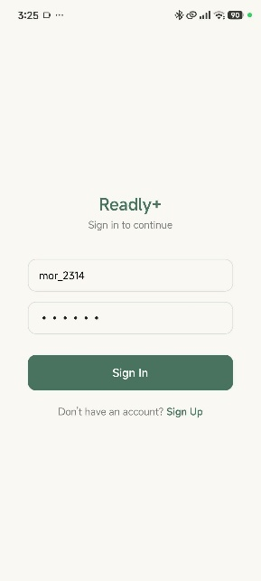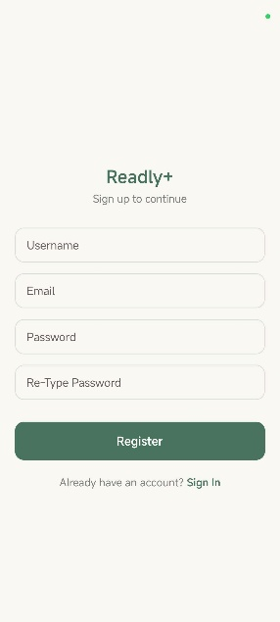
Userflow ketika ingin masuk ke detail book, diwajibkan login jika belum login
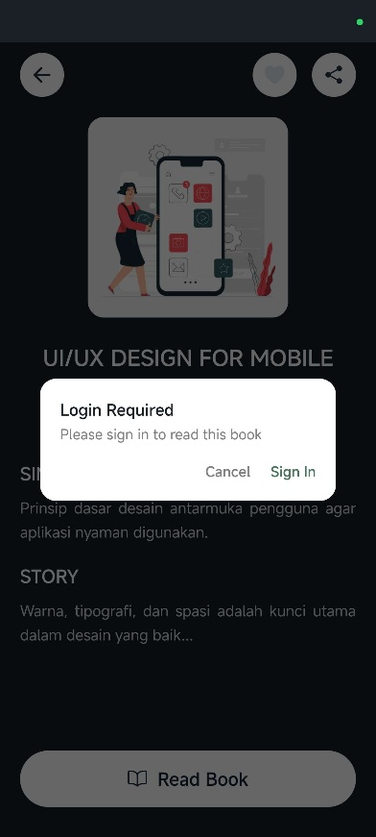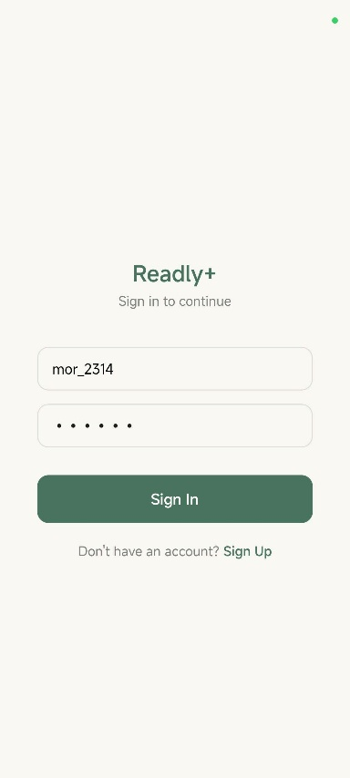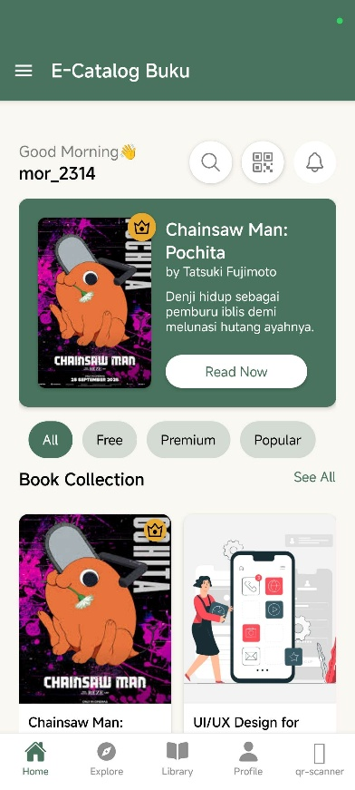
Output/Hasil Screenshot dari ketika suatu buku premium, diwajibkan subscribe
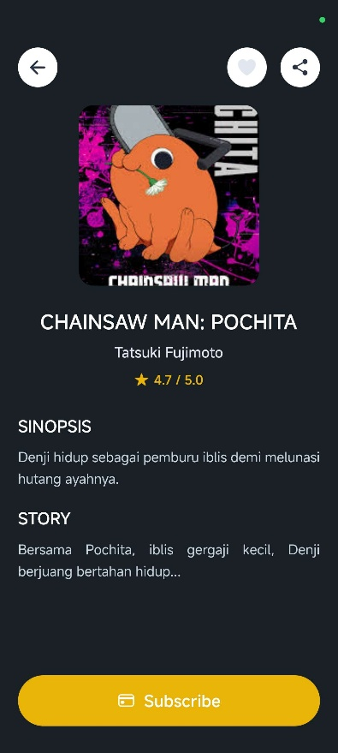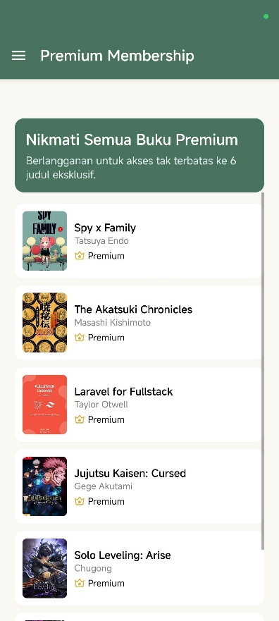

Output/Hasil jika suatu buku gratis, dan selain itu jika sudah premium, ketika buku card detail tersebut dibuka, akan menampilkan tampilan khusus detail book
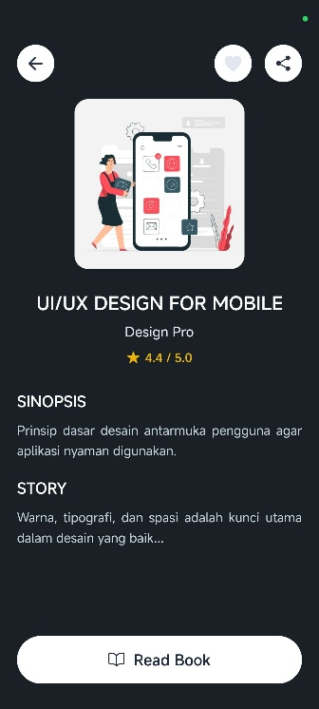
Berikut jika ingin login, dan memvalidasi untuk Sign Out, ketika Sign Out, akan menghapus token pada local storage/session habis setelah Sign Out
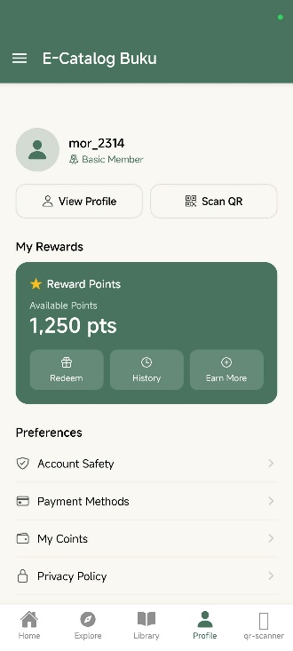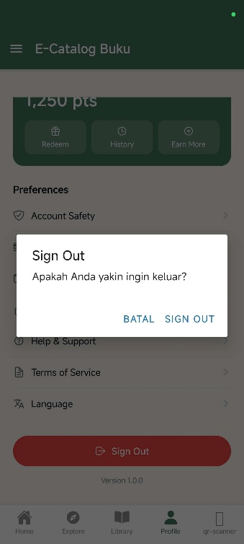
- Upload project tersebut pada GITHUB yang telah dibuat sebelumnya di repository "PPB-Praktikum-NPM", namun commit dengan nama "Tugas Praktikum-8".
- Pengumpulan Tugas Latihan Praktikum dikumpulkan selama 1 minggu kedepan sejak hari ini (sesuai dengan jadwal praktikum).
LINK REPOSITORY
https://github.com/RicoSteven120206/PPB-Praktikum-242310037.git

